Write UP

(A00258753)

# Description

The Valet Parking system is created and ready to use it creates a link list using the LinkList class and it allows users to maintain the system of car parking. It saves some important information at the time a car is parked like car parking number, car name, car number and the time of parking of the car. Each new car is stored as a node in the link list.

It also generates the amount that needs to be paid by the customer. I have set the amount to be 3 euros for an hour. The Application calculates the number of hours the car was parked in the system and displays the cost accordingly.

**public** String cost(**int** n) {

Park temp = head;

**int** p = 0;

**while**(temp!=**null**) {

p = temp.p();

**if**(n==p) {

Date d = **new** Date();

String c = temp.cost(d,temp.pd);

delete(n);

**return** c;

}

temp=temp.next;

}

**return** "No Car Found in this slot";

}

The above mentioned code helps in detecting cost for a particular car the parameter that is passed in the above function is the parking number of the particular car.   
The while loop in the function travels the whole list, and if it founds a car parked at that place it generates the cost for parking using below function in class Park.

**public** String cost(Date d1, Date d2) {

// **TODO** Auto-generated method stub

**long** diff = d1.getTime() - d2.getTime();

**long** mins = diff / (60 * 1000) % 60;

**long** hrs = diff / (60 * 60 * 1000);

**int** cost = (**int**) (hrs * 3);

**if**(mins>0) {

cost = cost + 3;

}

**return** "€"+cost;

}

This returns back the cost to the function and then we delete the node from the list and return the cost to user interface.

Screenshorts

**GUI**

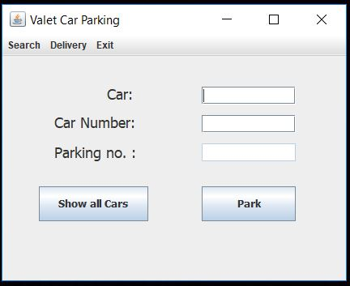

**Search**

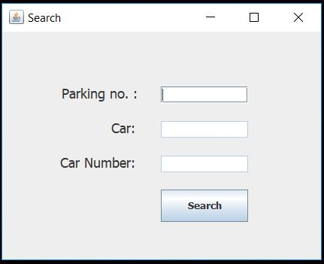

**Delivery**

